Functional Programming is all about seperation concern, like OOP. Structure data

Generally FP emphasis on simplicity where data and functions are concern. FP has same goal as OOP

Concept of pure functions. All objects created in functional program is immutable.

We avoid things like shared state

Pure function

1. A function has to always return same output given the same input
2. Function cannot modify anything outside itself, no side effect

Can anything be pure? No – program can’t really exist without side effect, the input and output itself already outside world. Interact with DOM etc.

The goal is to minimize side effect

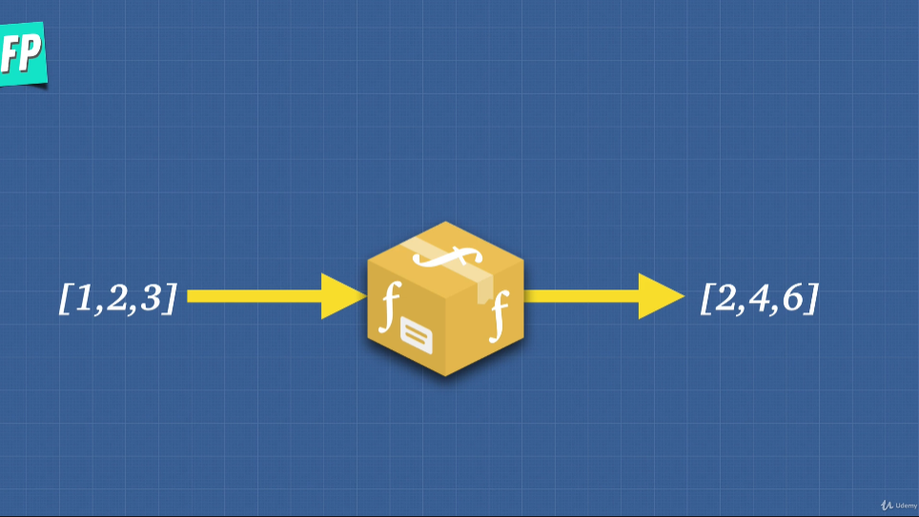

Pure function should

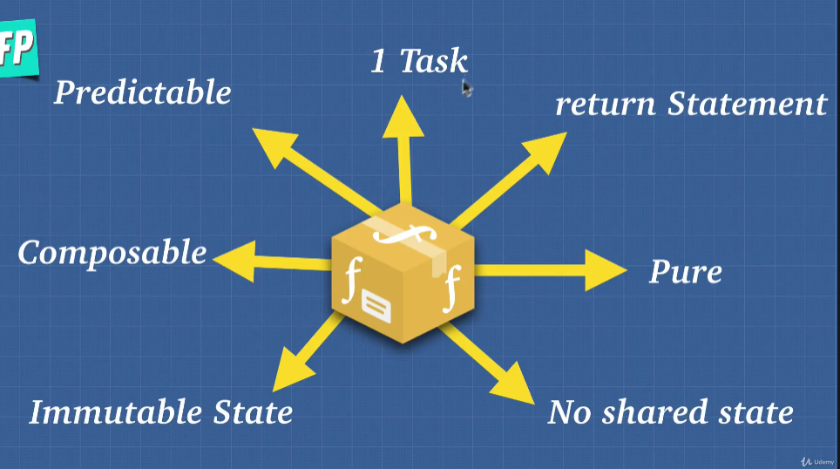

1. One task only
2. Always return something
3. Pure
4. No shared state
5. Modify state within our function, return a new copy of the output. Not modify outside
6. Composable
7. Predictable